

Colegio Nuestro Tiempo - R.B.D.: 14.507-6
Teacher of English Language: Francisca Alvarez P.
Guía de trabajo
Idioma extranjero: Inglés
Quinto Básico
Semana 1

Name: ____________________________________________________________ Date: March 17th, 2020

Total score: 44 points Score: ____________ Mark: ___________________
OBJECTIVES | - To recognize personal pronouns and numbers from 1 to 50.  - To identify vocabulary related to Unit: Home Time  - To apply vocabulary related to Unit 1: Home time

Review Last year
I. Personal pronouns.

We use the personal pronouns to replace people, places or things to make sentences shorter and clearer.
The personal pronouns are:
I am | You are | We are | They are | He is | She is | It is
Yo soy | Tu eres | Nosotros somos | Ellos son | El es | Ella es | Eso es  (usado para animales y/o cosas)

II. Numbers from 1 to 50

1 one 6 six 11 eleven 16 sixteen 30 Thirty

2 two 7 seven 12 twelve 17 seventeen 40 Forty

3 three 8 Eight 13 thirteen 18 eighteen 50 Fifty

4 four 9 Nine 14 fourteen 19 nineteen

5 five 10 Ten 15 fifteen 20 twenty

Unit 1: Home time
Tidy my room  Ordenar mi cuarto | Walk the dog  Pasear el perro | See my friends  Ver a mis amigos | Have dinner  Cenar | Do my homework  Hacer la tarea
Go to bed  Ir a la cama | Do the dishes  Lavar los platos | Listening to music  Escuchar musica | Do sports  Hacer deporte | Play videogames  Jugar video juegos

Frequency adverbs

We use it to talk about how often something happens.

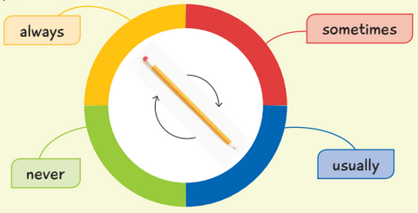
Always: Siempre

Usually: Usualmente

Sometimes: Algunas veces

Never: Nunca

Activity 1
I. Personal Pronouns.
Look at the pictures and write the correct PERSONAL PRONOUN. (7pts)

 |  | 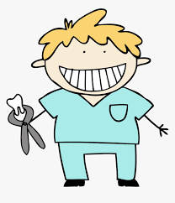
T__________________ Chefs | ________________ a doctor | ______________ a dentist

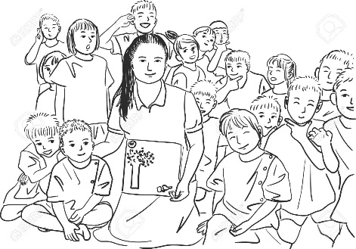 |  |  | 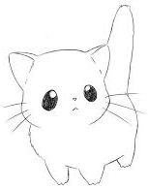
W___________students | ______________ Pedro | Y______________ small | ___________ a cat!

II. Numbers
Solve the maths problems. (23pts)
A) Write the name of the following numbers

1
2
3
6
10
12
13

15
18
19
20
30
40
50

B) Solve the math problems.

Ten + thirty – twenty =
Fourteen + five =
Six × one =
Seventeen + Three – Four =
Ten ÷ two =

Thirteen + three -three =
One + three =
Fourteen ÷ two
Eight + Nine – Eight =

Activity 2
I. Reading comprehension
Go to your STUDENT’S BOOK page 20 and read “The adventures of Beep”. Then, circle if it’s TRUE or FALSE in your book. (2pts)

II. Writing
Go to your ACTIVITY BOOK and complete the activities page 8, 9 and 11 (12pts)

