

Colegio Nuestro Tiempo - R.B.D.: 14.507-6
Teacher of English Language: Francisca Alvarez P.
Guía de trabajo
Idioma extranjero: Inglés
Cuarto Básico
Semana 1

Name: ____________________________________________________________ Date: March 20 ^{th}, 2020

Total score: 44 points Score: ____________ Mark: ___________________
OBJECTIVES | - To recognize personal pronouns and numbers from 1 to 50.  - To identify vocabulary related to Unit: Time for school  - To apply vocabulary related to Unit 1: Time for school

Review Last year
I. Personal pronouns.

We use the personal pronouns to replace people, places or things to make sentences shorter and clearer.
The personal pronouns are:
I am | You are | We are | They are | He is | She is | It is
Yo soy | Tu eres | Nosotros somos | Ellos son | El es | Ella es | Eso es  (usado para animales y/o cosas)

II. Numbers from 1 to 50

1 one 6 six 11 eleven 16 sixteen 30 Thirty

2 two 7 seven 12 twelve 17 seventeen

3 three 8 Eight 13 thirteen 18 eighteen

4 four 9 Nine 14 fourteen 19 nineteen

5 five 10 Ten 15 fifteen 20 twenty

Activity 1
I. Personal Pronouns.
Look at the pictures and write the correct PERSONAL PRONOUN. (7pts)

 |  | 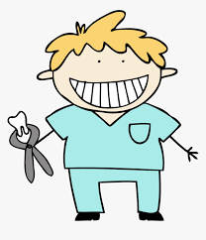
T__________________ Chefs | ________________ a doctor | ______________ a dentist

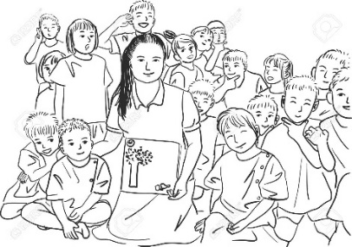 |  |  | 
W___________students | ______________ Pedro | Y______________ small | ___________ a cat!

II. Numbers
A) Write the name of the following numbers (12 pts)

1
2
3
6
10
12
13

15
18
19
20
30

B) Solve the math problems. (9 pts)

Ten + thirty – twenty =
Fourteen + five =
Six × one =
Seventeen + Three – Four =
Ten ÷ two =

Thirteen + three -three =
One + three =
Fourteen ÷ two
Eight + Nine – Eight =

Activity 2
I. Match the subjects. (8pts)

Arte Information Technologies
Ciencia Maths
Musica Physical Education
Ingles Arts
Lenguaje Science
Matematica English
Educacion física Music
Informacion tecnológica Spanish

II. Go to your ACTIVITY BOOK page 7 and 8 and do the tasks. Feel free to use the dictionary or google!

