

Colegio Nuestro Tiempo - R.B.D.: 14.507-6
Teacher of English Language: Francisca Alvarez P.
Guía de trabajo
Idioma extranjero: Inglés
Segundo Básico
Semana 1

Name: ____________________________________________________________ Date: March 19 ^{th}, 2020

Total score: 20 points Score: ____________ Mark: ___________________
OBJECTIVES | - To recognize personal pronouns and numbers from 1 to 10.  - To identify vocabulary related to Unit: Time for school  - To apply vocabulary related to Unit 1: Time for school

Review Last year
I. Personal pronouns.

We use the personal pronouns to replace people, places or things to make sentences shorter and clearer.
The personal pronouns are:
I am | He is | She is
Yo soy | El es | Ella es

II. Numbers from 1 to 10

1 one 2 Two 3 three 4 four 5 five

6 six 7 seven 8 eight 9 Nine 10 Ten

Activity 1
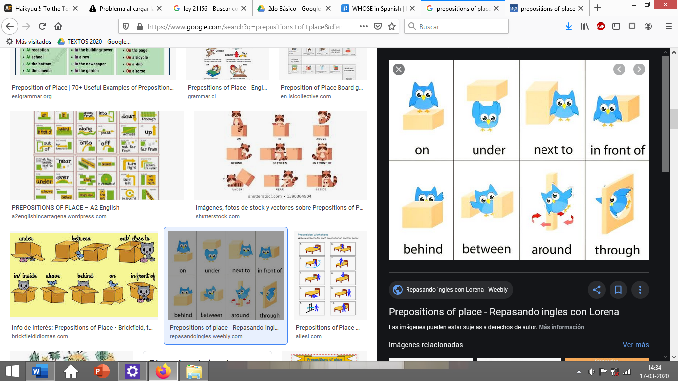
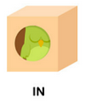
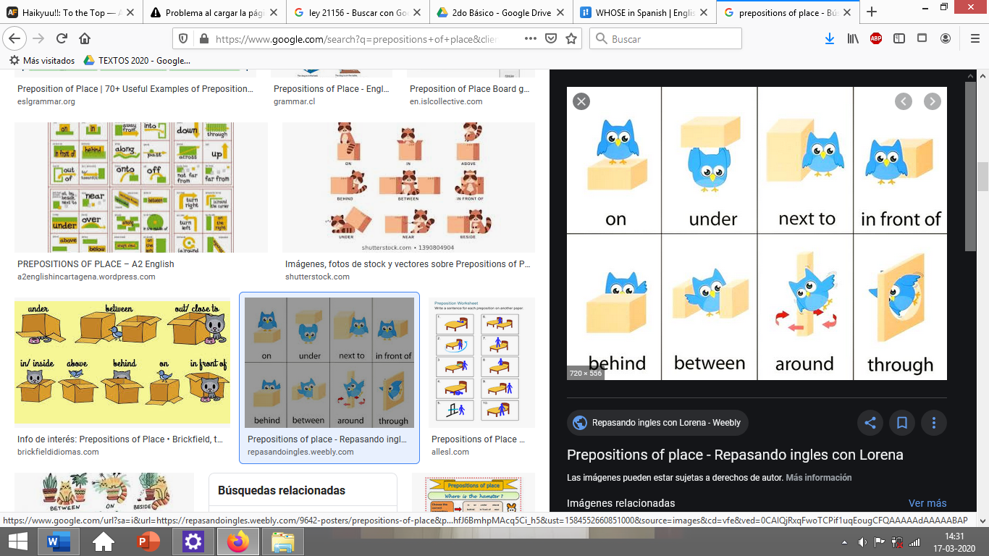

I. Draw a ball according to the preposition/Dibuja una pelota de acuerdo a la preposición de lugar. (5pts)

BEHIND | ON | IN | UNDER

II. Go to your ACTIVITY BOOK and answer the activities from page 6. (5pts)
III. Go to your ACTIVITY BOOK and answer the activities from page 9. (5pts)
IV. Go to your ACTIVITY BOOK and answer the activities from page 11. (5pts)

