

Colegio Nuestro Tiempo - R.B.D.: 14.507-6
Teacher of English Language: Francisca Alvarez P.
Guía de trabajo N° 2
Idioma extranjero: Inglés
Octavo Básico
Semana 2 y 3

Name: _________________________________________________________ Date: March 25th and April 1st, 2020
Total score: 56 points Score: ___________ Mark: ___________________
OBJECTIVE | - To apply vocabulary related to Unit 1: Information and communication technologies.

Grammar References
I. Personal pronouns.
We use the personal pronouns to replace people, places or things to make sentences shorter and clearer.
The personal pronouns are:
I am | You are | We are | They are | He is | She is | It is

II. Numbers from 1 to 1.000.000

1 one 6 six 11 eleven 16 sixteen 30 Thirty 80 Eighty

2 two 7 seven 12 twelve 17 seventeen 40 Forty 90 Ninety

3 three 8 Eight 13 thirteen 18 eighteen 50 Fifty 100 One hundred

4 four 9 Nine 14 fourteen 19 nineteen 60 Sixty 1.000 One thousand

5 five 10 Ten 15 fifteen 20 twenty 70 seventy 1.000.000 One million

Possessives: We use possessive pronouns to talk about something that we have.
Mine Mio
Yours Tuyo
His suyo (de él)
Hers suya (de ella)
Ours Nuestro
Theirs de ellos
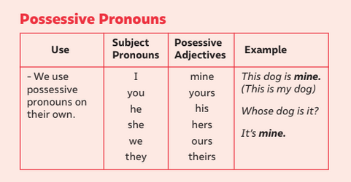

Be Going to: we use it for plans or predictions based on concrete evidence.
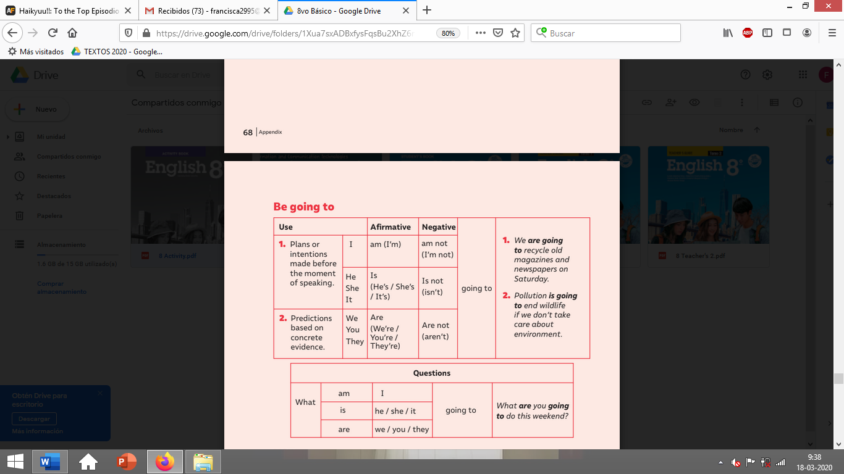
Activities
I. Create sentences using be going to and all the personal pronouns. (16 pts)
e.g. S + verb to be + going to + verb + complement.

Affirmative
a)
b)
c)
d)
e)
f)
g)
Negative
a)
b)
c)
d)
e)
f)
g)
Interrogative

a)
b)
-II. Go to your STUDENT’S BOOK and complete the activities from page 9-10-11 and 12. (20 pts). Feel free to use dictionary or google to help you in the tasks!

III. Go to your STUDENT’S BOOK page 14 and create a COMIC STRIP related to “THE USE OF APPS” (20pts)
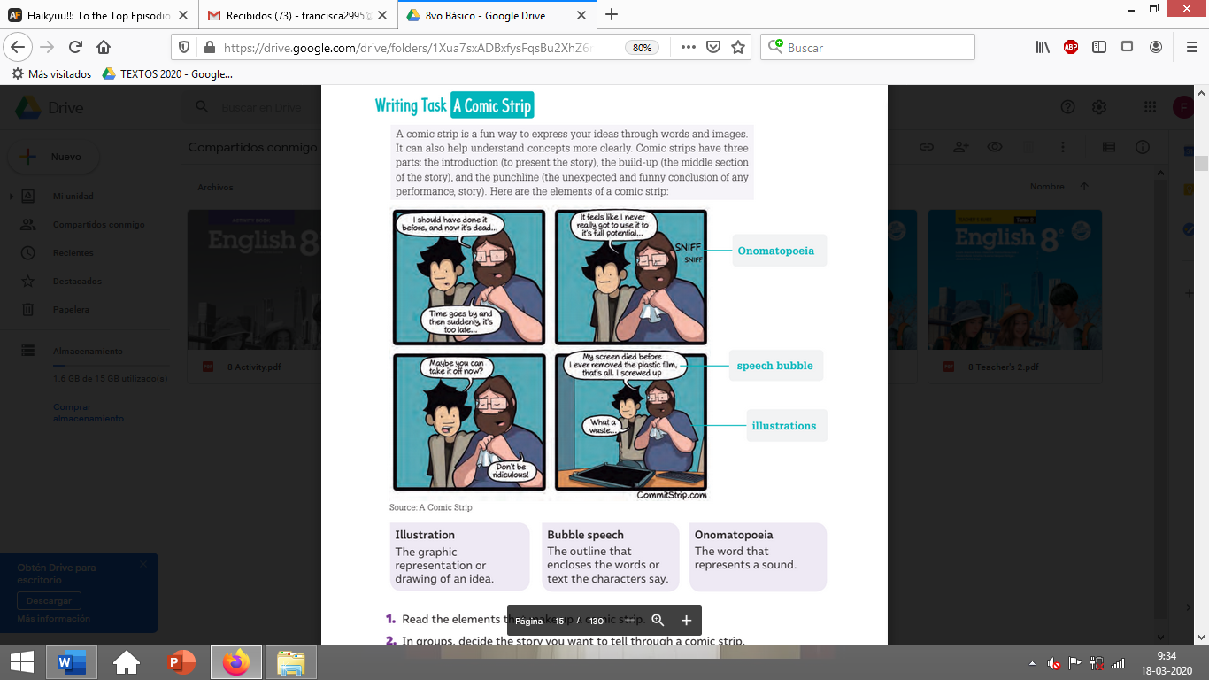
**This activity is individually**

