

Colegio Nuestro Tiempo - R.B.D.: 14.507-6
Teacher of English Language: Francisca Alvarez P.
Guía de trabajo N°2
Idioma extranjero: Inglés
Septimo Básico
Semana 2

Name: ____________________________________________________________ Date: March 26th, 2020

Total score: 60 points Score: ____________ Mark: ___________________
OBJECTIVE | - To apply vocabulary related to Unit 1: Feelings and Opinions

Grammar References
I. Personal pronouns.
We use the personal pronouns to replace people, places or things to make sentences shorter and clearer.
The personal pronouns are:
I am | You are | We are | They are | He is | She is | It is

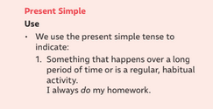
I. Present simple
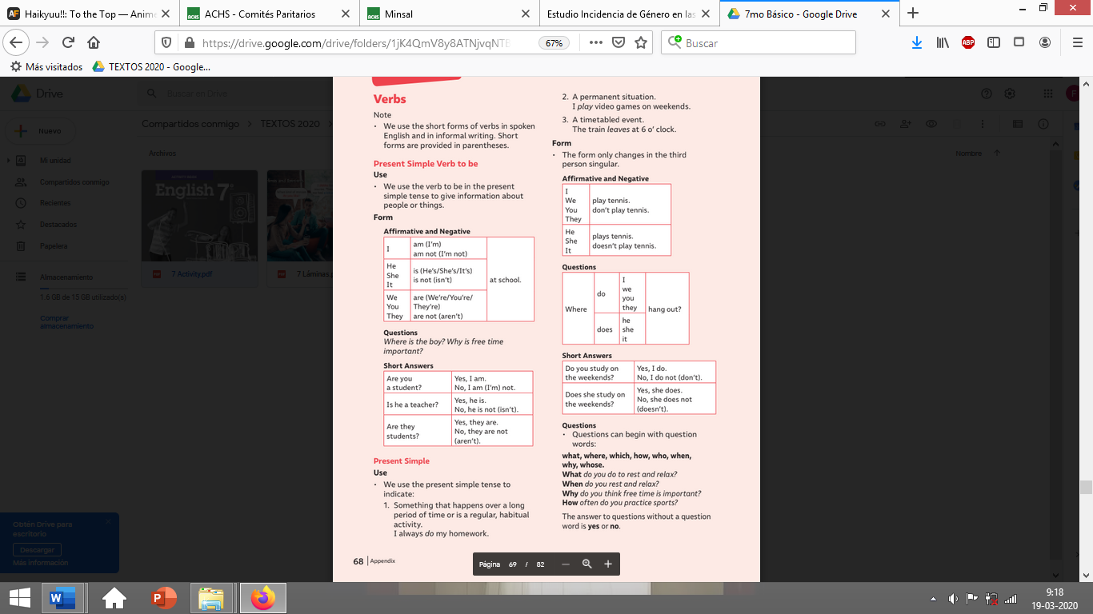
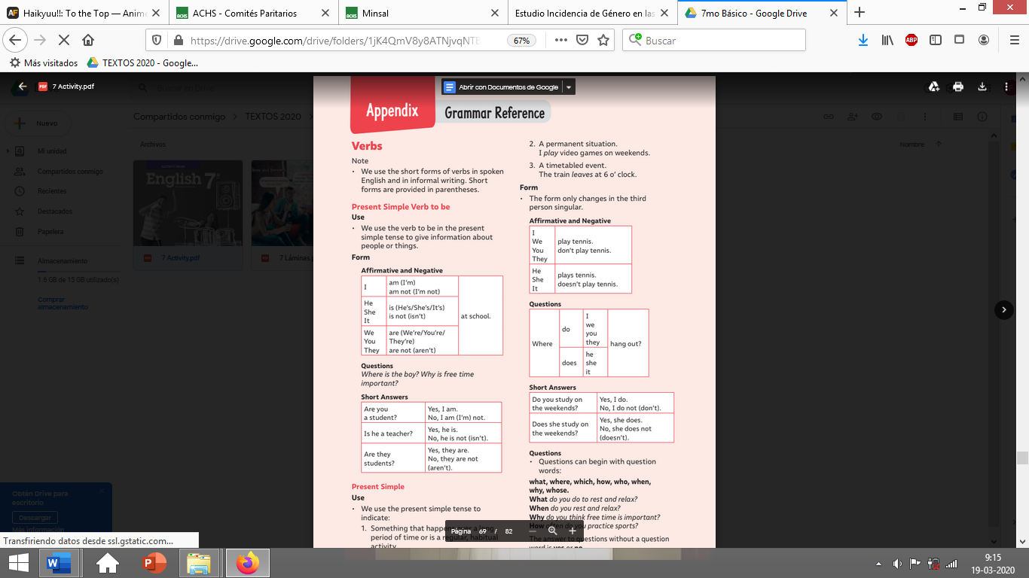
Verb to be : AM - IS - ARE

Structure:

S + VERB TO BE
Example
You + ARE + beautiful(adj)
He + IS + a boy (compl)
I + AM + smart (adj)

Present Simple Structure:

AFFIRMATIVE: S + VERB + COMPLEMENT
NEGATIVE: S + DON’T/ DOESN’T + VERB + COMPLEMENT
INTERROGATIVE: DO/DOES + S + VERB + COMPLEMENT +?

E.G He + play + soccer (aff)
He + doesn’t + play + soccer (neg)
Does + he + play + soccer? (inte)
INTERROGATIVE

We use DO/DON’T with personal pronouns I – YOU – WE – THEY

We use DOES/ DOESN’T with personal pronouns HE – SHE IT.

Activities
I. Personal pronouns and verb to be
Look at the personal pronoun and write the correct form of the verb to be (12 pts)

- Clara and I ______ best friend.
- Cata and Javi ______ classmates.
- Nico _______ your brother.
- Mary _______ a good student.
- They _______ eating “sopaipas” in the classroom.
- ________ Tom your cat?
- I ______ a great student!
- John, Anthony and Chris ______ friends.
- _____ I a good person?
- It _______ a book bag.
- You _______ a doctor.
- ________ we friends forever?

Unit 1: Feelings and Opinions

I. Translate the following words into Spanish. (6 points)

a) HAPPY: __________________________________ b) ANGRY: __________________________________

c) TIRED: __________________________________ d) SCARED: __________________________________

e) SLEEPY: _________________________________ f) FRIENDLY: _________________________________

II. Translate the following intensifiers and adjectives (6 pts)

a) SO: _____________________________________ b) REALLY: _________________________________

c) A LITTLE: _________________________________ d)SUPER: __________________________________

e) A BIT: ___________________________________ f) VERY: ___________________________________

III. Go to your ACTIVITY BOOK and complete the activities from page 7 (16 pts) and 8. (8pts). Feel free to use dictionary or google to help you in the tasks!

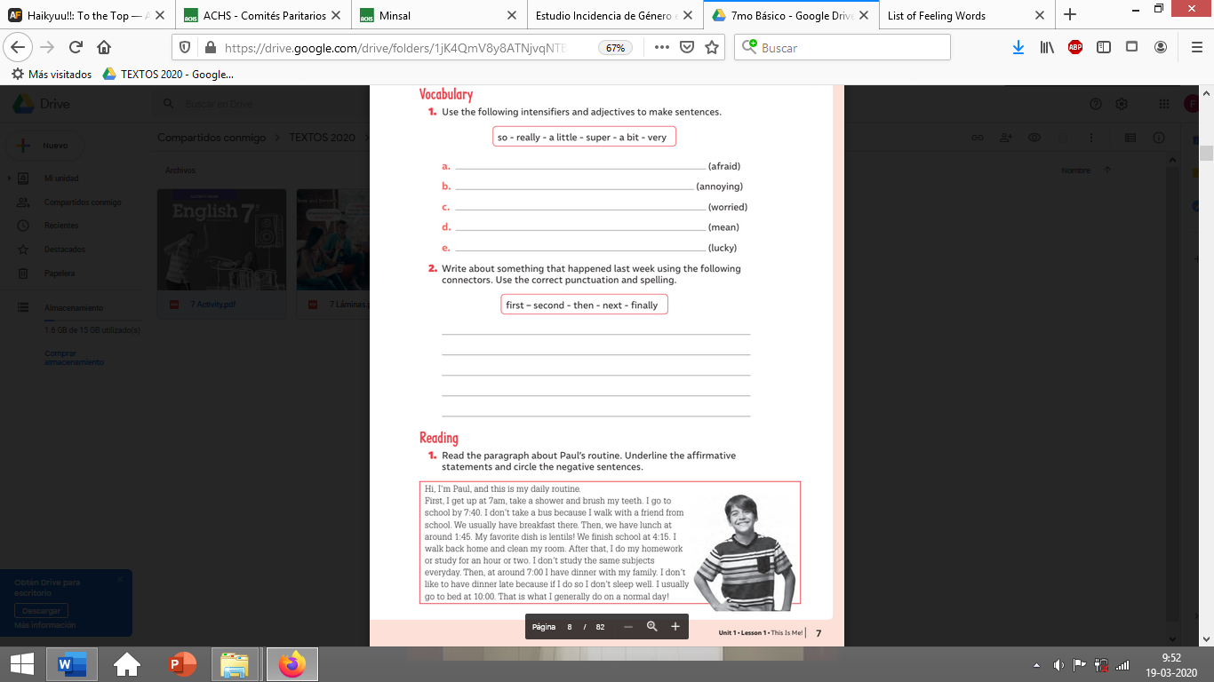
Page 7

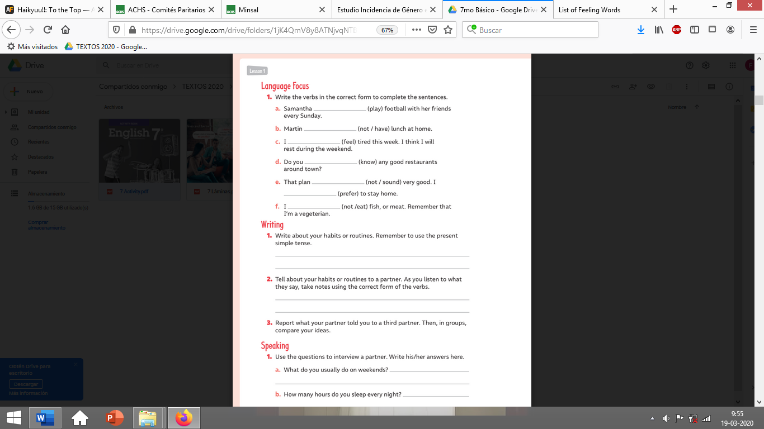
Page 8

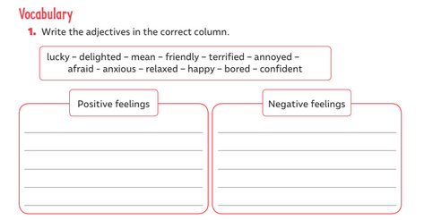
III. Go to your ACTIVITY BOOK and complete the activity 1” Vocabulary” from page 9 (12 pts). Feel free to use dictionary or google to help you in the tasks!

