

Colegio Nuestro Tiempo - R.B.D.: 14.507-6
Teacher of English Language: Francisca Alvarez P.
Guía de trabajo N°2
Idioma extranjero: Inglés
Sexto Básico
Semana 2

Name: ____________________________________________________________ Date: March 25th, 2020

Total score: 25 points Score: ____________ Mark: ___________________
OBJECTIVE | - To apply vocabulary related to Unit 1: Food and Health

Grammar reference
I. Personal pronouns.
We use the personal pronouns to replace people, places or things to make sentences shorter and clearer.
The personal pronouns are:
I am | You are | We are | They are | He is | She is | It is

II. Present simple
Present Simple Structure:

AFFIRMATIVE: S + VERB + COMPLEMENT

Example
I + drink + juice
He + eats + banana

NEGATIVE: S + DON’T + VERB + COMPLEMENT

Example
I don’t eat chicken
You don’t drink tea
We don’t cook
They don’t wash the carrots

S + DOESN’T + VERB + COMPLEMENT

Example
HE doesn’t eat eggs
SHE doesn’t drink milk
IT doesn’t smell good

INTERROGATIVE: DO + S + VERB + COMPLEMENT +?
DOES + S + VERB + COMPLEMENT +?

Example
Do I eat potatoes?
Do you drink water?
Do we eat spaghetti today?
Do they cook soup?
Does he eat onions?
Does she cook smash potatoes?
Does it drink water?
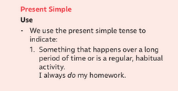

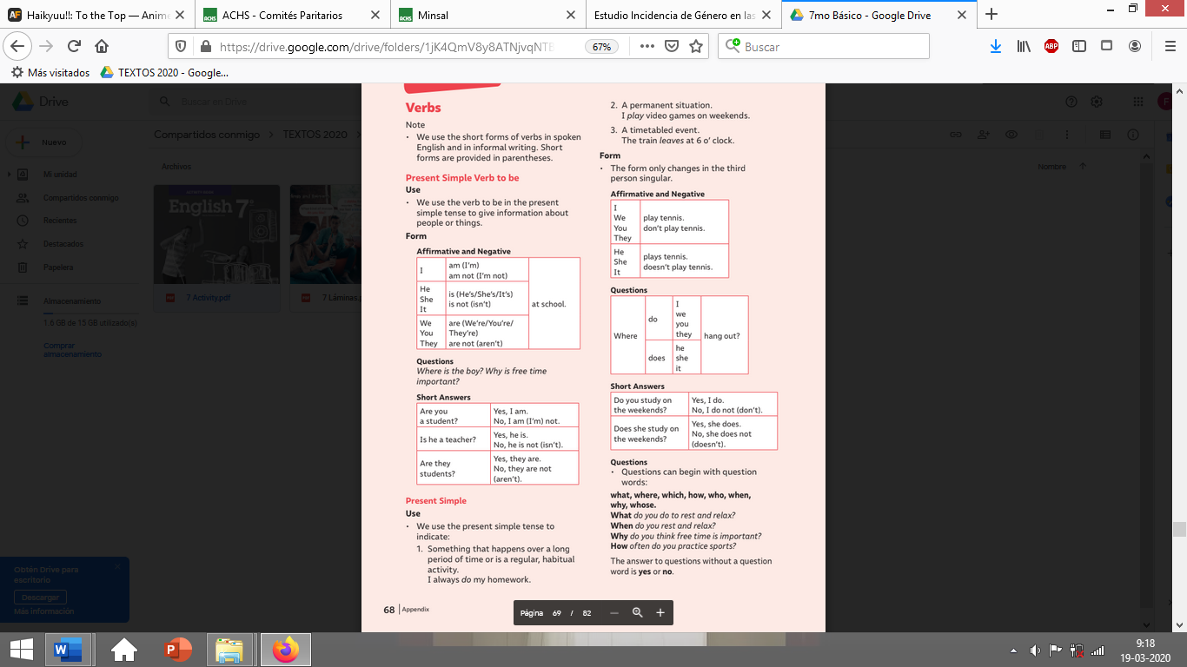

**REMEMBER**

We use DO/DON’T with personal pronouns:
I – YOU – WE – THEY

We use DOES/DOESN’T with personal pronouns:
HE – SHE – IT
I. Circle the correct option according to the subject. (8pts)
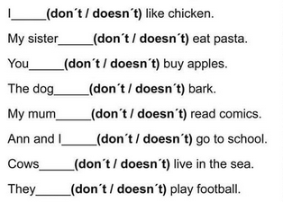

Grammar reference of the 3rd Person Rules

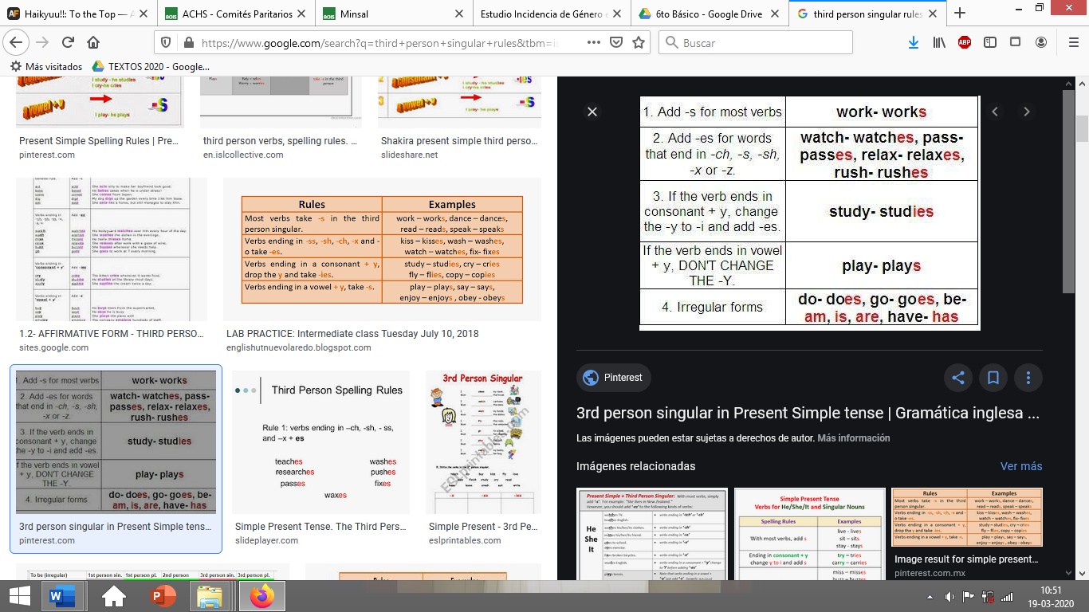

II. Write the correct form of the verb using the third person rules. (5 pts)
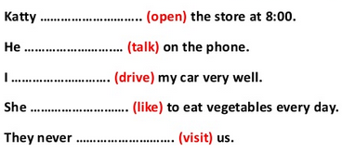

III. Translate the following words into Spanish. (6 pts)

a) ONIONS _______________________ b) SMASH POTATOES: ________________________

c) GARLIC: _______________________ d) CABBAGE: ________________________________

e) FRENCH FRIES: _________________ F) WATERMELON: ___________________________

II. Look at the picture and write what all these people and you LIKE or DON’T LIKE to eat for lunch. (6 pts)
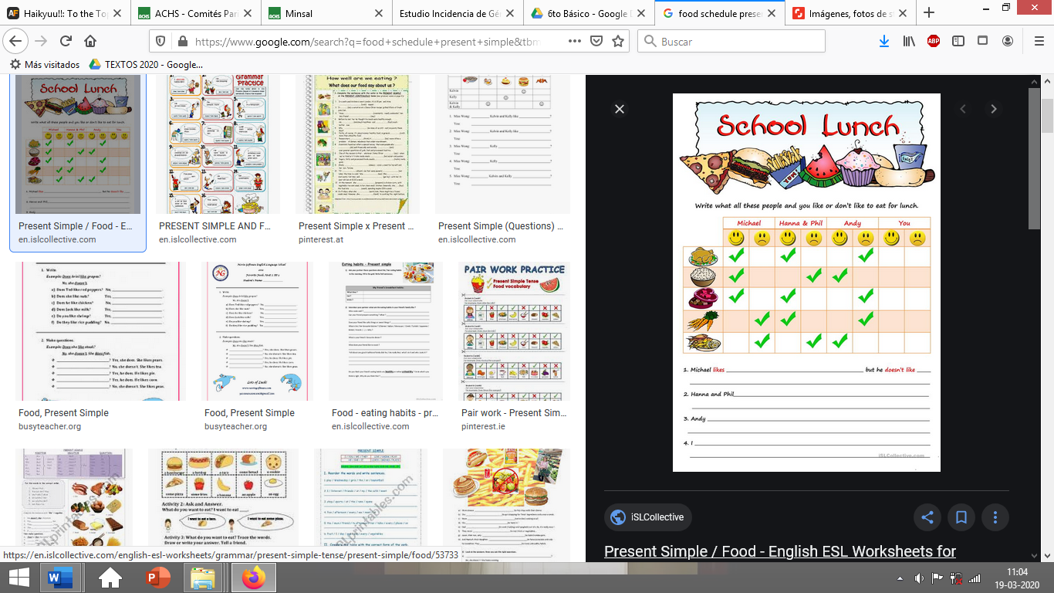

1. MICHAEL likes ______________________________________________________________________
but he doesn’t like ____________________________________________________________________.

2. HANNA and PHIL ____________________________________________________________________
But_________________________________________________________________________________ .

3. Andy ______________________________________________________________________________
But _________________________________________________________________________________ .

Food images: CHICKEN – RICE – CHOCOLATES – CARROTS – FISH AND CHIPS

