

Colegio Nuestro Tiempo - R.B.D.: 14.507-6
Teacher of English Language: Francisca Alvarez P.
Guía de trabajo N°2
Idioma extranjero: Inglés
Quinto Básico
Semana 2

Name: ____________________________________________________________ Date: March 24th, 2020

Total score: 16 points Score: ____________ Mark: ___________________
OBJECTIVE | - To apply vocabulary related to Unit 1: Home time

Grammar reference
I. Personal pronouns.
We use the personal pronouns to replace people, places or things to make sentences shorter and clearer.
The personal pronouns are:
I am | You are | We are | They are | He is | She is | It is

II. Numbers from 1 to 50

1 one 6 six 11 eleven 16 sixteen 30 Thirty

2 two 7 seven 12 twelve 17 seventeen 40 Forty

3 three 8 Eight 13 thirteen 18 eighteen 50 Fifty

4 four 9 Nine 14 fourteen 19 nineteen

5 five 10 Ten 15 fifteen 20 twenty

Unit 1: Home time
Tidy my room  Ordenar mi cuarto | Walk the dog  Pasear el perro | See my friends  Ver a mis amigos | Have dinner  Cenar | Do my homework  Hacer la tarea
Go to bed  Ir a la cama | Do the dishes  Lavar los platos | Listening to music  Escuchar musica | Do sports  Hacer deporte | Play videogames  Jugar video juegos

Frequency adverbs

We use it to talk about how often something happens.

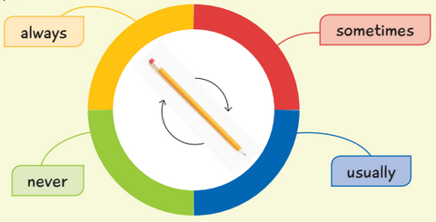
Always: Siempre

Usually: Usualmente

Sometimes: Algunas veces

Never: Nunca

Activites
I. Write sentences using frequency adverbs and verbs from the box. (4 pts)

1) Play 2) Do 3) Walk 4) See

a) I N_________ ____________ the dog.
b) I U __________ ___________ my friends.
c) I A ______________ ________ my homework.
d) I S_______________ ________ video games

II. Go to your ACTIVITY BOOK and complete the activity 8 page 12 (12 pts)
