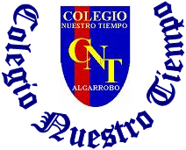

Colegio Nuestro Tiempo - R.B.D.: 14.507-6
Teacher of English Language: Francisca Alvarez P.
Guía de trabajo N°2
Idioma extranjero: Inglés
Cuarto Básico
Semana 2

Name: ____________________________________________________________ Date: March 27 ^{th}, 2020

Total score: 18 points Score: ____________ Mark: ___________________
OBJECTIVE | - To apply vocabulary related to Unit 1: Time for school

Grammar reference
I. Personal pronouns.
We use the personal pronouns to replace people, places or things to make sentences shorter and clearer.
The personal pronouns are:

I am | You are | We are | They are | He is | She is | It is

II. Numbers from 1 to 30

1 one 6 six 11 eleven 16 sixteen 30 Thirty

2 two 7 seven 12 twelve 17 seventeen

3 three 8 Eight 13 thirteen 18 eighteen

4 four 9 Nine 14 fourteen 19 nineteen

5 five 10 Ten 15 fifteen 20 twenty

III. School items
PEN | PENCIL | PENCILCASE | SHARPENER | RULER | RUBBER | BOOK | SHOOLBAG
boligrafo | lápiz | estuche | sacapuntas | regla | goma | libro | mochila
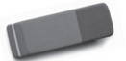
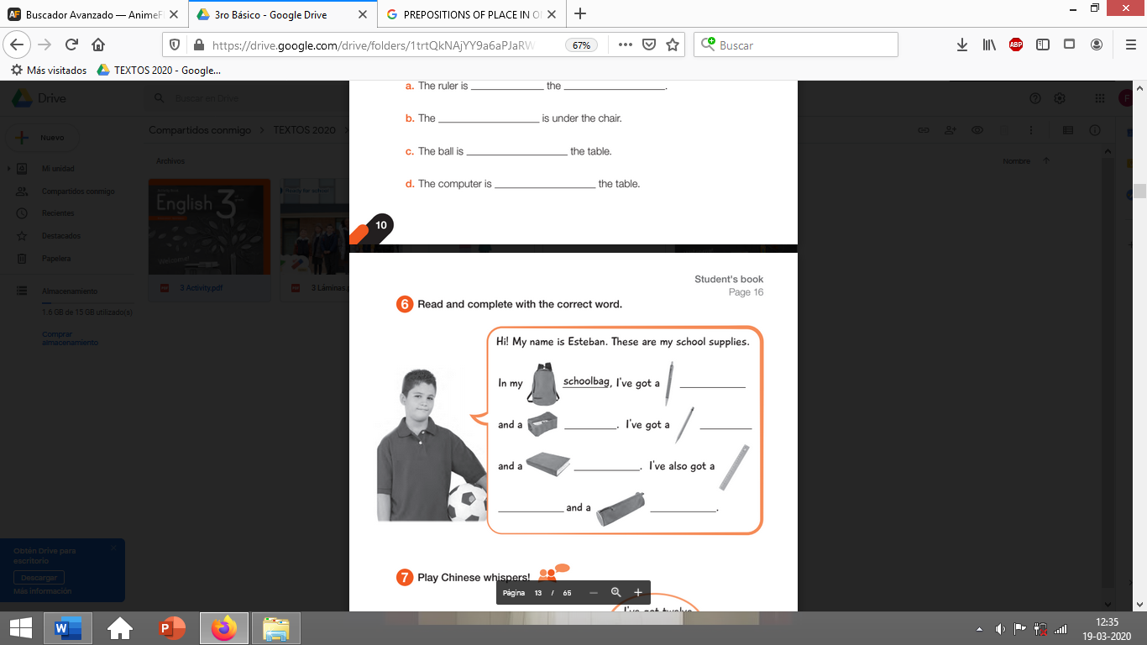

Activities
I. Complete the crossword using numbers. (10 pts)

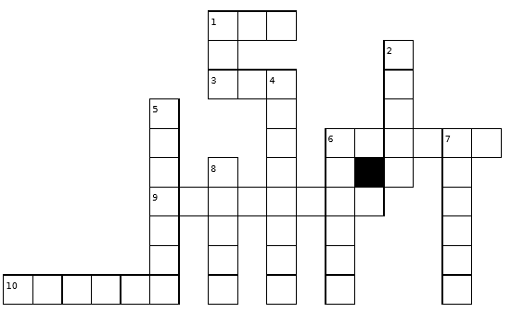

Clues
Down Across

1) number 2 1) number 10
2) number 3 3) number 1
4) number 18 6) number 20
5) number 15 9) number 9
6) number 12 10) number 11
7) number 30
8) number 8

II. Go to your activity book page 10 and complete the activities using the box below. (8 pts)
