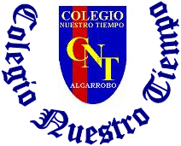

Colegio Nuestro Tiempo - R.B.D.: 14.507-6
Teacher of English Language: Francisca Alvarez P.
Guía de trabajo N° 2
Idioma extranjero: Inglés
Tercero Básico
Semana 2

Name: ____________________________________________________________ Date: March 25 ^{th}, 2020

Total score: 14 points Score: ____________ Mark: ___________________
OBJECTIVE | - To apply vocabulary related to Unit 1: Ready for school

Grammar reference
I. Personal pronouns.
We use the personal pronouns to replace people, places or things to make sentences shorter and clearer.
The personal pronouns are:
I am | He is | She is
Yo soy | El es | Ella es

II. Numbers from 1 to 20

1 one 6 six 11 eleven 16 sixteen

2 two 7 seven 12 twelve 17 seventeen

3 three 8 Eight 13 thirteen 18 eighteen

4 four 9 Nine 14 fourteen 19 nineteen

5 five 10 Ten 15 fifteen 20 twenty

III. Prepositions of place IN – ON -UNDER -BEHIND

In on under behind
IV. School items
PEN | PENCIL | PENCILCASE | SHARPENER | RULER | RUBBER | BOOK | SHOOLBAG
boligrafo | lápiz | estuche | sacapuntas | regla | goma | libro | mochila
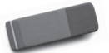
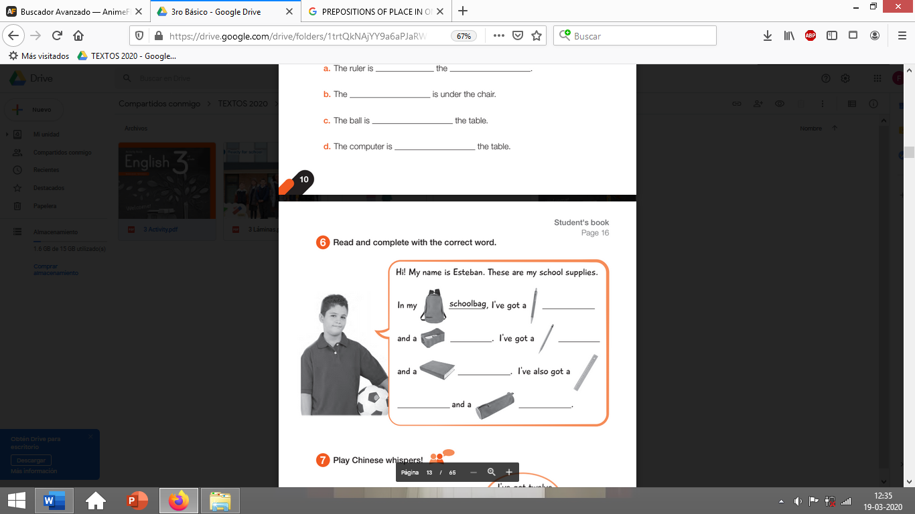

Activity 1
I. Go to your ACTIVITY BOOK and answer the activities from page 10 (8 pts)
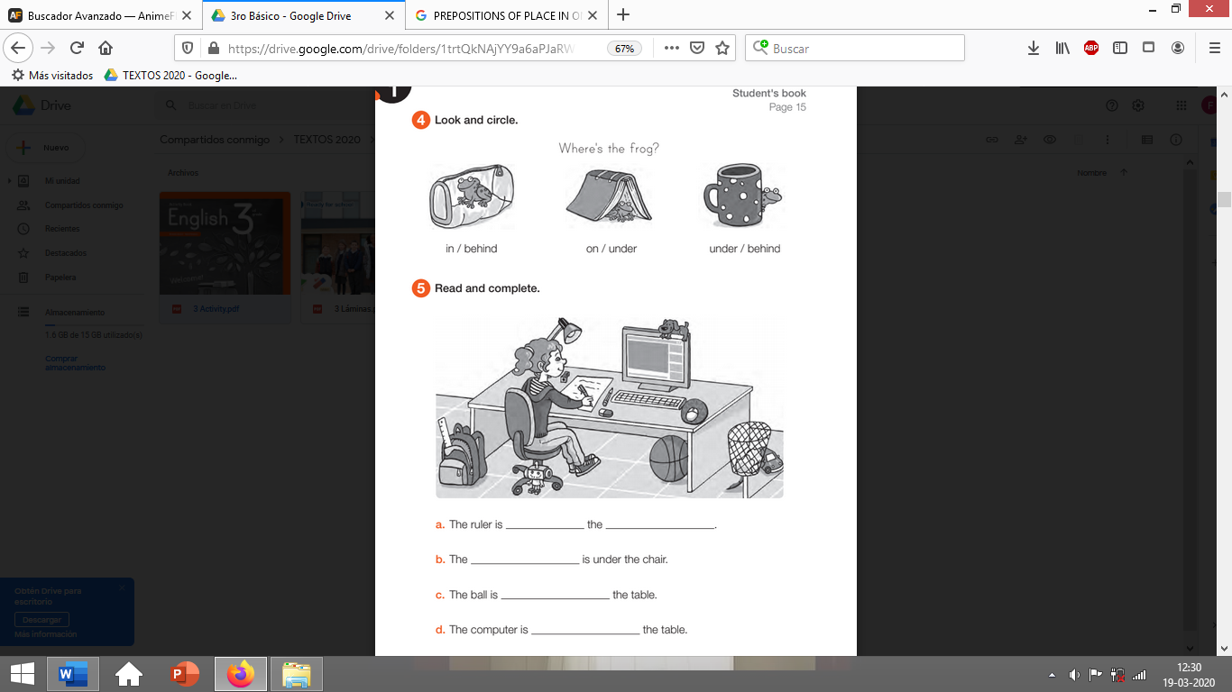

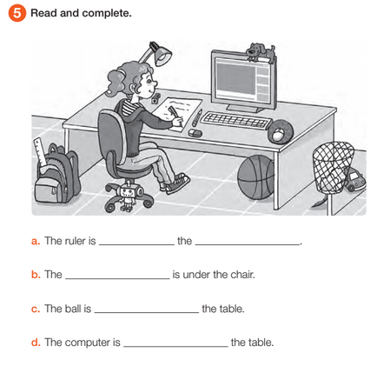

II. Go to your ACTIVITY BOOK and answer the activity 6 from page 11 (6 pts)

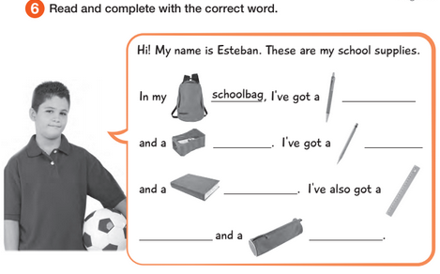
page 11

