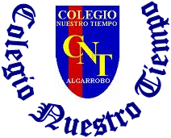

Colegio Nuestro Tiempo - R.B.D.: 14.507-6
Teacher of English Language: Francisca Alvarez P.
Guía de trabajo N°2
Idioma extranjero: Inglés
Segundo Básico
Semana 2

Name: ____________________________________________________________ Date: March 26 ^{th}, 2020

Total score: 18 points Score: ____________ Mark: ___________________
OBJECTIVE | - To apply vocabulary related to Unit 1: Time for school

Grammar reference
I. Personal pronouns.
We use the personal pronouns to replace people, places or things to make sentences shorter and clearer.
The personal pronouns are:
I am | He is | She is
Yo soy | El es | Ella es

II. Numbers from 1 to 10

1 one 2 Two 3 three 4 four 5 five

6 six 7 seven 8 eight 9 Nine 10 Ten

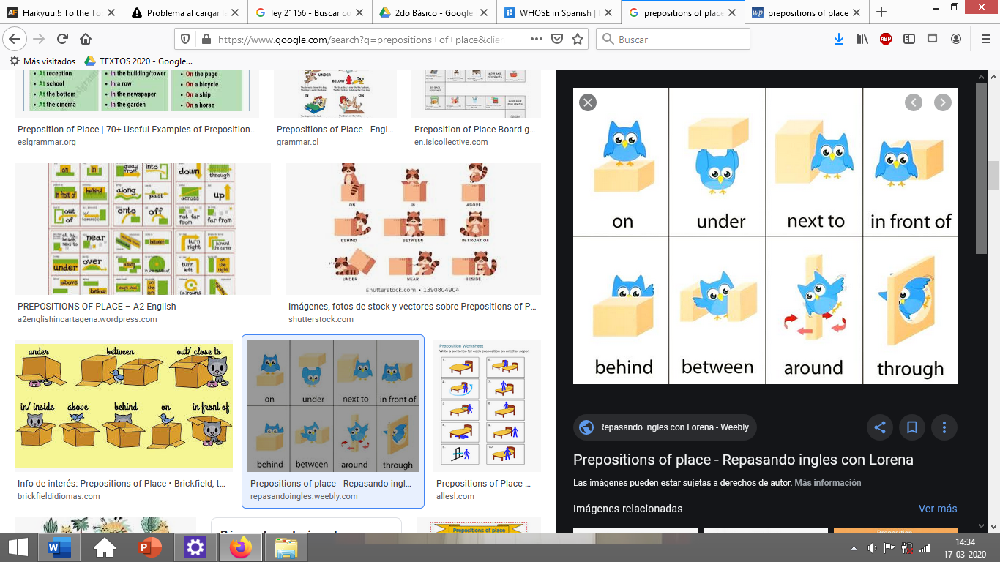
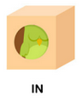
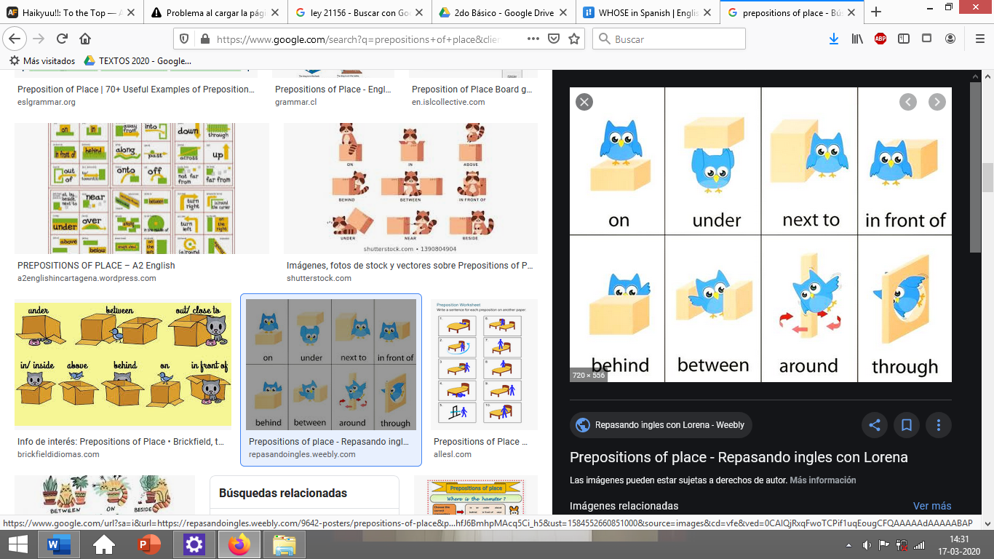

III. School items
PEN | PENCIL | PENCILCASE | SHARPENER | RULER | RUBBER | BOOK | SHOOLBAG
boligrafo | lápiz | estuche | sacapuntas | regla | goma | libro | mochila
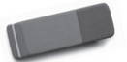
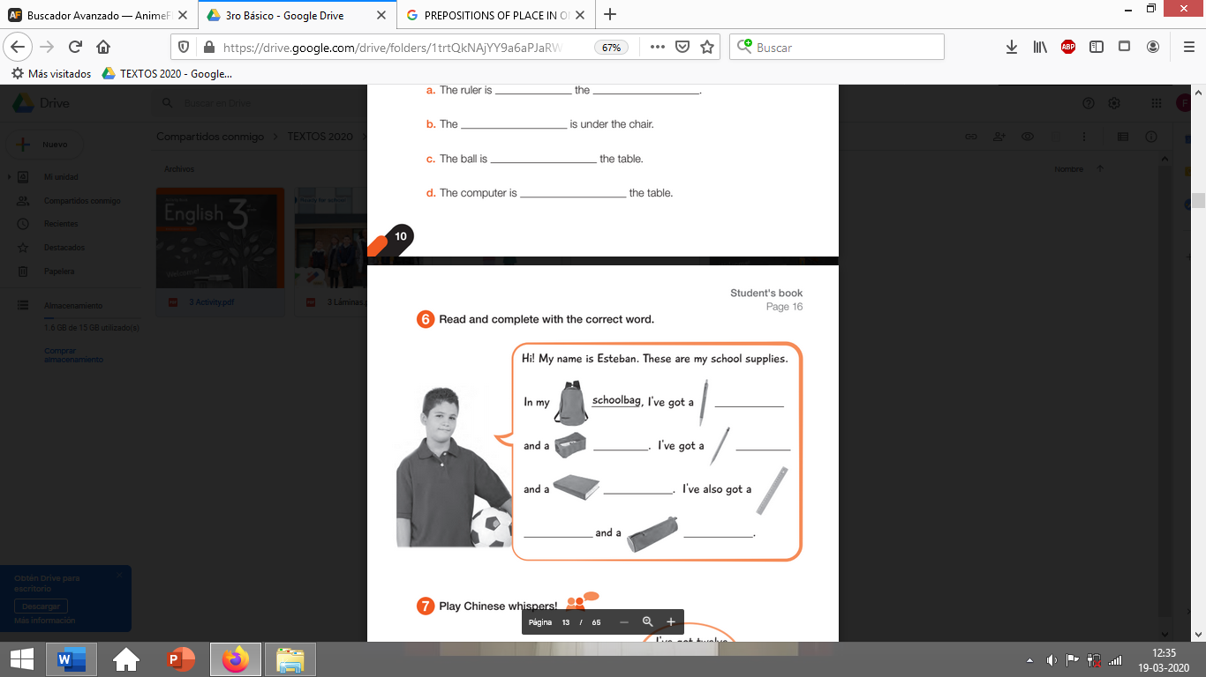

Activities
I. find the school items in the wordsearch. (8pts)

S | H | A | R | P | E | N | E | R
C | X | R | W | E | I | S | D | U
H | E | F | N | N | A | T | B | B
O | A | I | G | C | U | F | O | B
O | X | U | O | I | P | G | O | E
L | M | R | U | L | E | R | K | R
B | D | Q | H | C | N | E | Y | A
A | C | P | I | A | V | N | M | Z
G | B | L | W | S | H | O | B | C
A | K | J | P | E | N | C | I | L

I. Go to your STUDENT’S BOOK and answer the activities from page 17. (5pts)
II. Go to your STUDENT’S BOOK and answer the activities from page 18. (5pts)

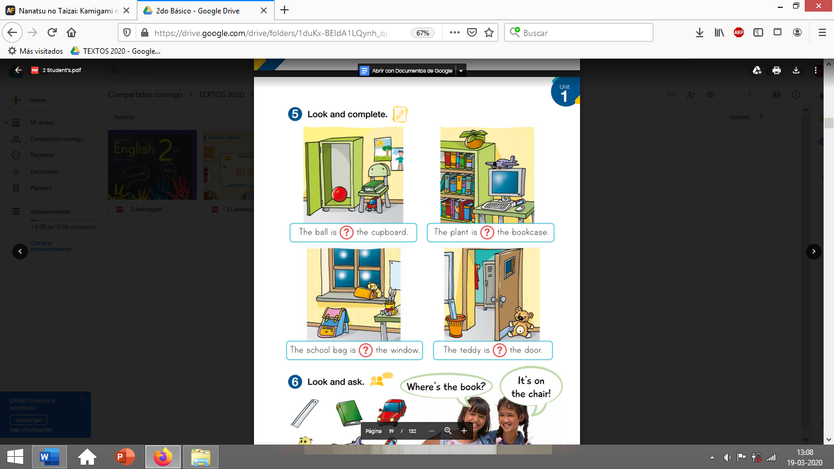
page 17

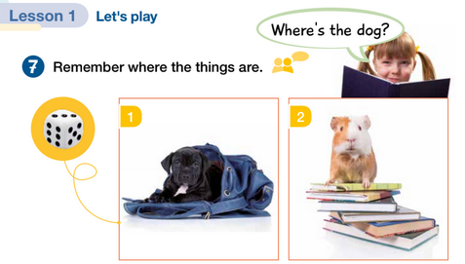
Page 18

