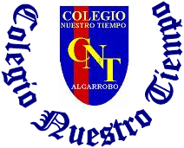

Colegio Nuestro Tiempo - R.B.D.: 14.507-6
Teacher of English Language: Francisca Alvarez P.
Guía de trabajo N°2
Idioma extranjero: Inglés
Primero Básico
Semana 2

Name: ____________________________________________________________ Date: March 26th, 2020

OBJECTIVE | - To apply vocabulary related to Unit 1: At school
Total score: 18 points Score: ____________ Mark: ___________________

Grammar reference
I. Numbers from 1 to 10

1 one 2 Two 3 three 4 four 5 five

6 six 7 seven 8 eight 9 Nine 10 Ten

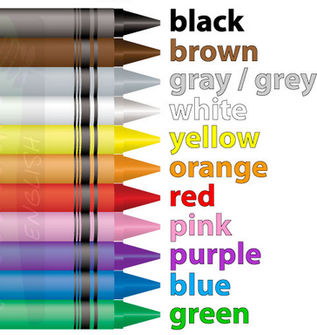
II. Colours

III. School items
PEN | PENCIL | PENCILCASE | SHARPENER | RULER | RUBBER | BOOK | SHOOLBAG
boligrafo | lápiz | estuche | sacapuntas | regla | goma | libro | mochila
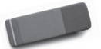
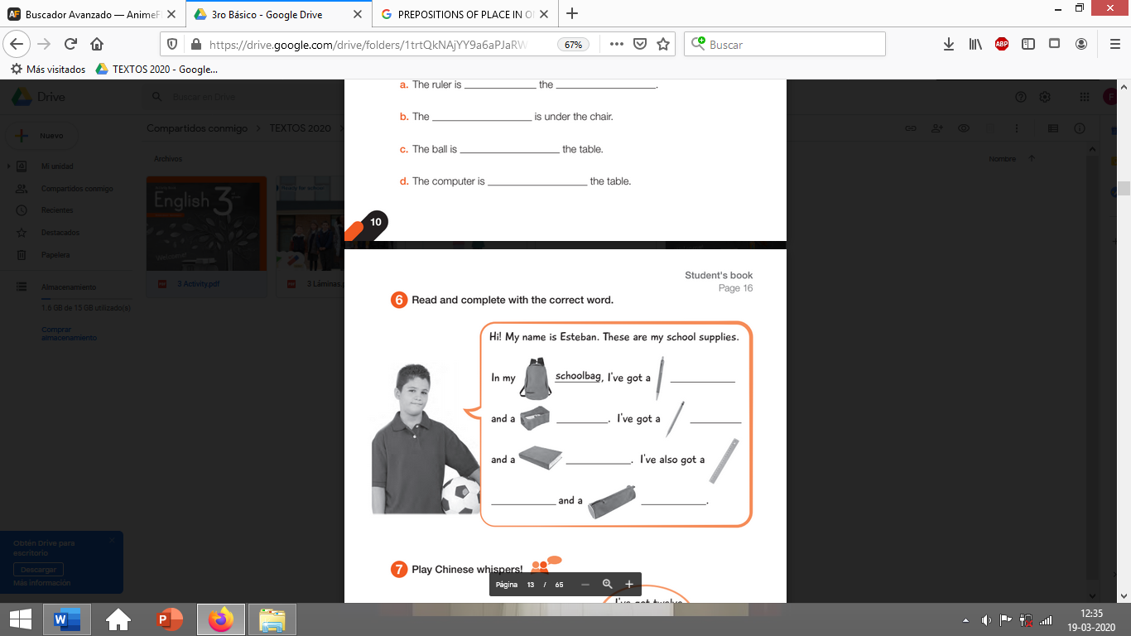

Activities
I. Draw the following school items. (3pts)

PENCIL CASE | RULER | BOOK

II. Go to your ACTIVITY BOOK and answer the activity 5 from page 11 (5pts)
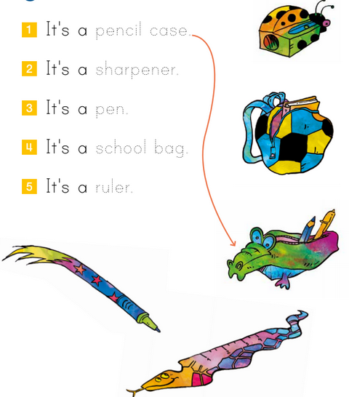

III. Find the numbers from 1 to ten. (10 pts)

one Two three four five

six seven eight Nine Ten

A | O | F | O | U | R | V | J | T
W | N | I | X | Q | P | I | K | W
S | E | V | E | N | M | P | M | O
I | S | E | I | A | T | E | N | V
X | U | F | G | S | T | S | I | A
B | D | O | H | L | R | T | N | B
S | C | H | T | H | R | E | E | C

