

Colegio Nuestro Tiempo - R.B.D.: 14.507-6
Teacher of English Language: Francisca Alvarez P.
Guía de trabajo N°4
Idioma extranjero: Inglés
Septimo Básico
Semana 4

Name: ____________________________________________________________ Date: April 9th, 2020

Total score: 30 points Score: ____________ Mark: ___________________
OBJECTIVE | - To recognize and describe feelings through texts.

Grammar References
I. Personal pronouns.
We use the personal pronouns to replace people, places or things to make sentences shorter and clearer.
The personal pronouns are:
I am | You are | We are | They are | He is | She is | It is

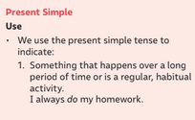
I. Present simple
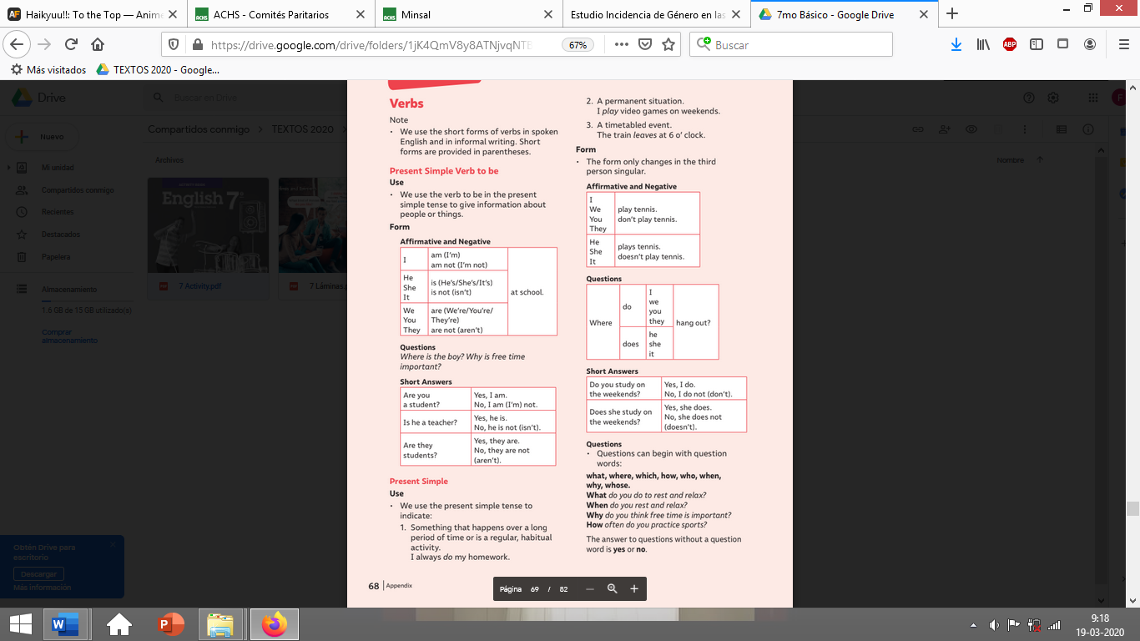
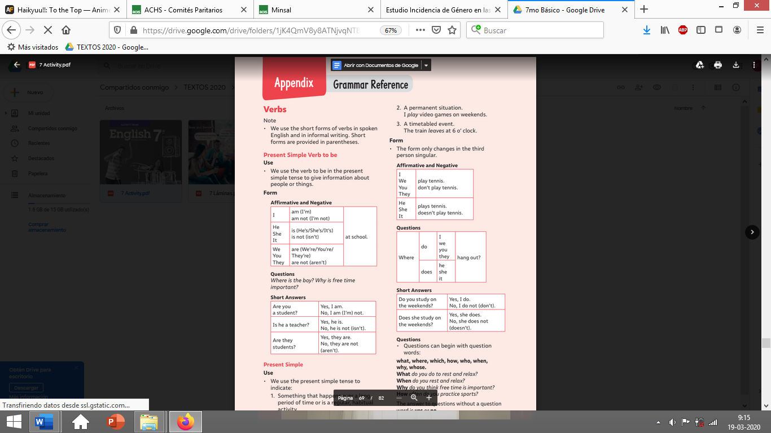
INTERROGATIVE

We use DO/DON’T with personal pronouns I – YOU – WE – THEY

We use DOES/ DOESN’T with personal pronouns HE – SHE IT.
Verb to be : AM - IS - ARE

Structure:

S + VERB TO BE
Example
You + ARE + beautiful(adj)
He + IS + a boy (compl)
I + AM + smart (adj)

Present Simple Structure:

AFFIRMATIVE: S + VERB + COMPLEMENT
NEGATIVE: S + DON’T/ DOESN’T + VERB + COMPLEMENT
INTERROGATIVE: DO/DOES + S + VERB + COMPLEMENT +?

E.G He + play + soccer (aff)
He + doesn’t + play + soccer (neg)
Does + he + play + soccer? (inte)
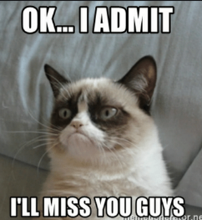

Unit 1: Feelings and Opinions

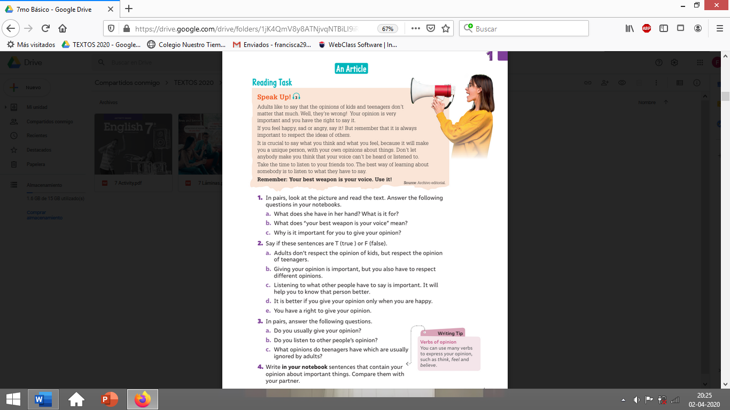
I. Go to your STUDENT’S BOOK and complete the activities from pages 13. Feel free to use dictionary or google to help you in the tasks! (10 pts)

I feel… yo siento…
I think… Yo pienso …
I believe … Yo creo…

II. Go to your ACTIVITY BOOK and complete the activities from page 10. Feel free to use dictionary or google to help you in the tasks! (20 pts) This task is INDIVIDUALLY.
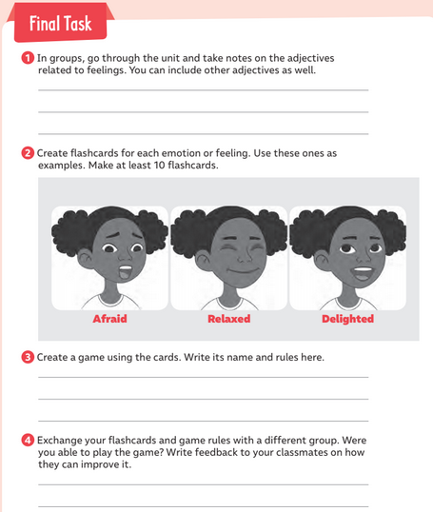

You can use anime faces, actors and actress faces, drawings, emojis, characters from video games, whatever you want.

Play with your FAMILY.

*Take a picture of your flashcards and send it by email. (idiomaextranjeroingles.cnt@gmail.com) *

Write your name in your flashcards and mail

