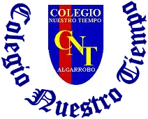

Colegio Nuestro Tiempo - R.B.D.: 14.507-6
Teacher of English Language: Francisca Alvarez P.
Guía de trabajo N° 4
Idioma extranjero: Inglés
Tercero Básico
Semana 4

Name: ____________________________________________________________ Date: April 8th, 2020

Total score: 15 points Score: ____________ Mark: ___________________
OBJECTIVE | - To make a poster about classroom rules

Grammar reference
I am | He is | She is
Yo soy | El es | Ella es
I. Personal pronouns.

Activity
II. Go to your Student’s book page 22 and Make a poster with rules to follow in your classroom. (15pts)
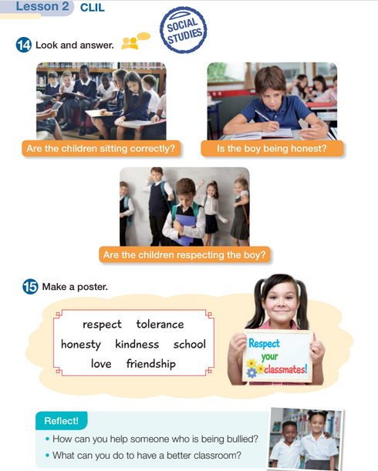
Take a picture of your poster and send it by email. (idiomaextranjeroingles.cnt@gmail.com)

Write your name in your poster

