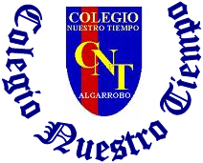

Colegio Nuestro Tiempo - R.B.D.: 14.507-6
Teacher of English Language: Francisca Alvarez P.
Guía de trabajo N°4
Idioma extranjero: Inglés
Segundo Básico
Semana 4

Name: ____________________________________________________________ Date: April 9th, 2020

Total score: 15 points Score: ____________ Mark: ___________________
OBJECTIVE | - To Make a poster related to classroom rules

Grammar reference
I. Personal pronouns.
I am | He is | She is
Yo soy | El es | Ella es

Activity

I. Go to your STUDENTS BOOK page 24 and make a poster with rules to follow in your classroom. (15 pts)
Take a picture of your poster and send it by email. (idiomaextranjeroingles.cnt@gmail.com)
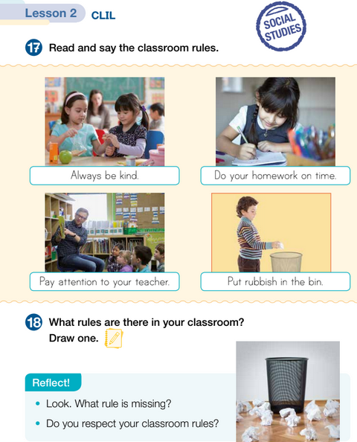

Write your name in your poster

