

Colegio Nuestro Tiempo - R.B.D.: 14.507-6
Teacher of English Language: Francisca Alvarez P.
Guía de trabajo N° 2
Idioma extranjero: Inglés
Octavo Básico
Semana 2 y 3

Name: _________________________________________________________ Date: March 25th and April 1st, 2020
Total score: 56 points Score: ___________ Mark: ___________________
OBJECTIVE | - To apply vocabulary related to Unit 1: Information and communication technologies and the use of be going to.

Grammar References
I. Personal pronouns.
We use the personal pronouns to replace people, places or things to make sentences shorter and clearer.
The personal pronouns are:
I am | You are | We are | They are | He is | She is | It is

II. Numbers from 1 to 1.000.000

1 one 6 six 11 eleven 16 sixteen 30 Thirty 80 Eighty

2 two 7 seven 12 twelve 17 seventeen 40 Forty 90 Ninety

3 three 8 Eight 13 thirteen 18 eighteen 50 Fifty 100 One hundred

4 four 9 Nine 14 fourteen 19 nineteen 60 Sixty 1.000 One thousand

5 five 10 Ten 15 fifteen 20 twenty 70 seventy 1.000.000 One million

Possessives: We use possessive pronouns to talk about something that we have.
Mine Mio
Yours Tuyo
His suyo (de él)
Hers suya (de ella)
Ours Nuestro
Theirs de ellos
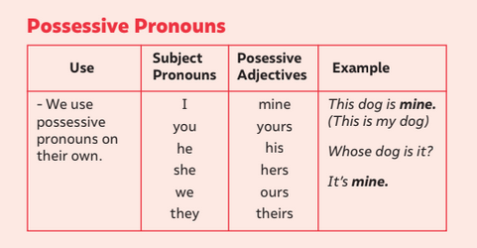

Be Going to: we use it for plans or predictions based on concrete evidence.
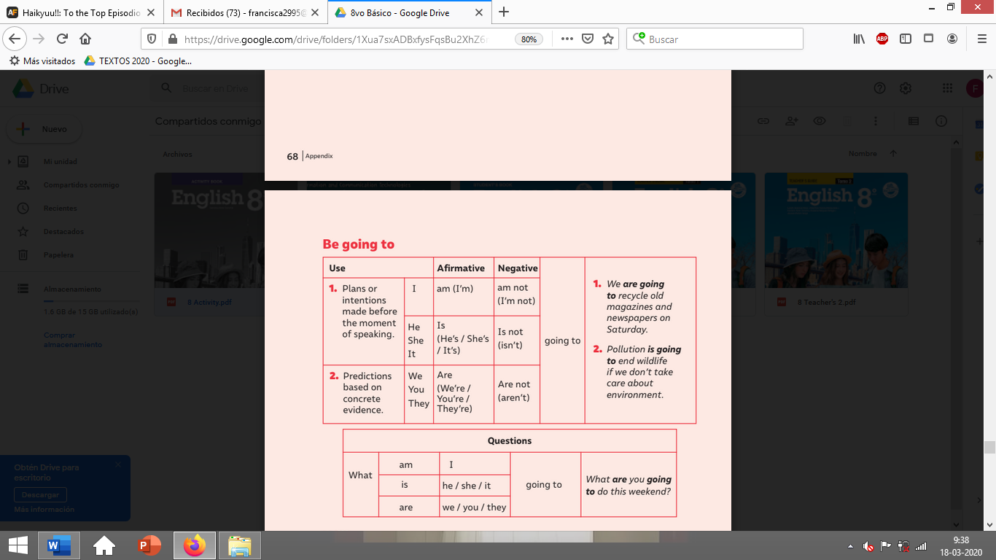
Activities
I. Create sentences using be going to and all the personal pronouns. (16 pts)
e.g.

Affirmative (S + verb to be + going to + verb + complement)

a)
b)
c)
d)
e)
f)
g)
Negative (S + verb to be + NOT + going to + verb + complement)

a)
b)
c)
d)
e)
f)
g)
Interrogative (verb to be + s + going to + verb + complement + ?)

a)
b)

II. Go to your STUDENT’S BOOK and complete the activities from page 9-10-11 and 12. (20 pts). Feel free to use dictionary or google to help you in the tasks!

III. Go to your STUDENT’S BOOK page 14 and create a COMIC STRIP related to “THE USE OF APPS” (20pts)
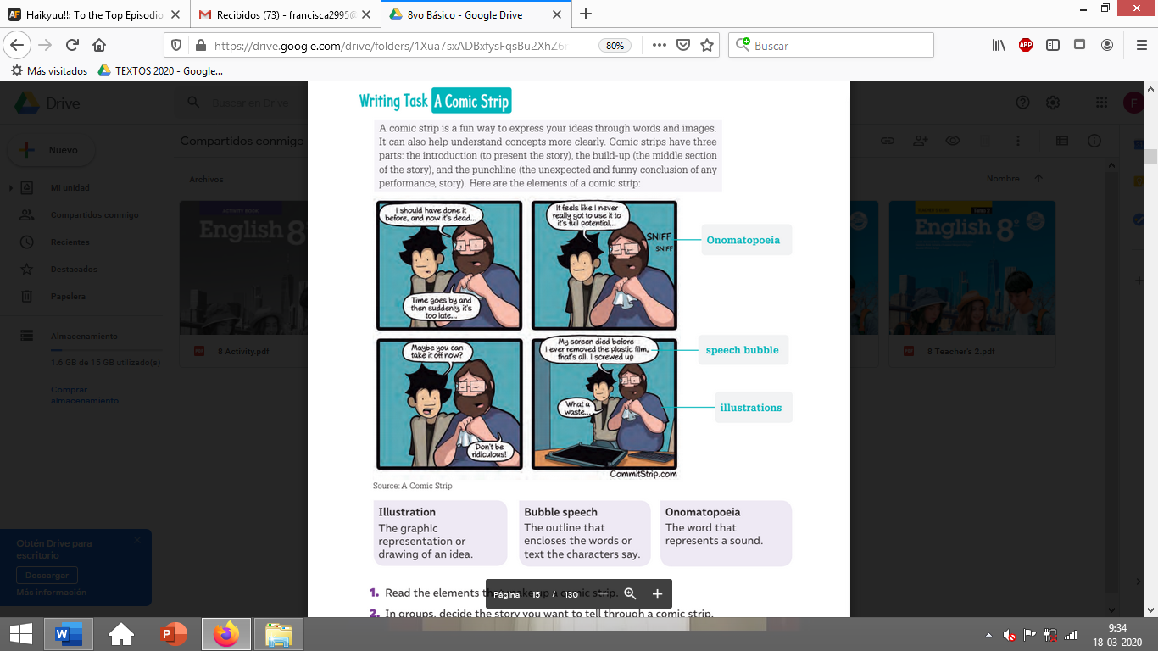
**This activity is individually**

