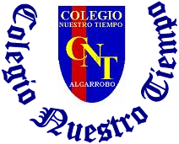

Colegio Nuestro Tiempo - R.B.D.: 14.507-6
Teacher of English Language: Francisca Alvarez P.
Guía de trabajo N° 3
Idioma extranjero: Inglés
Octavo Básico
Semana 4

Name: _________________________________________________________ Date: April 8th, 2020
Total score: 40 points Score: ___________ Mark: ___________________
OBJECTIVE | - To recognize and use modal verbs SHOULD and SHOULDN’T .

Grammar References
I. Personal pronouns.
We use the personal pronouns to replace people, places or things to make sentences shorter and clearer.
The personal pronouns are:
I am | You are | We are | They are | He is | She is | It is

II. Possessives: We use possessive pronouns Be Going to: we use it for plans or predictions
to talk about something that we have. base on concrete evidence.
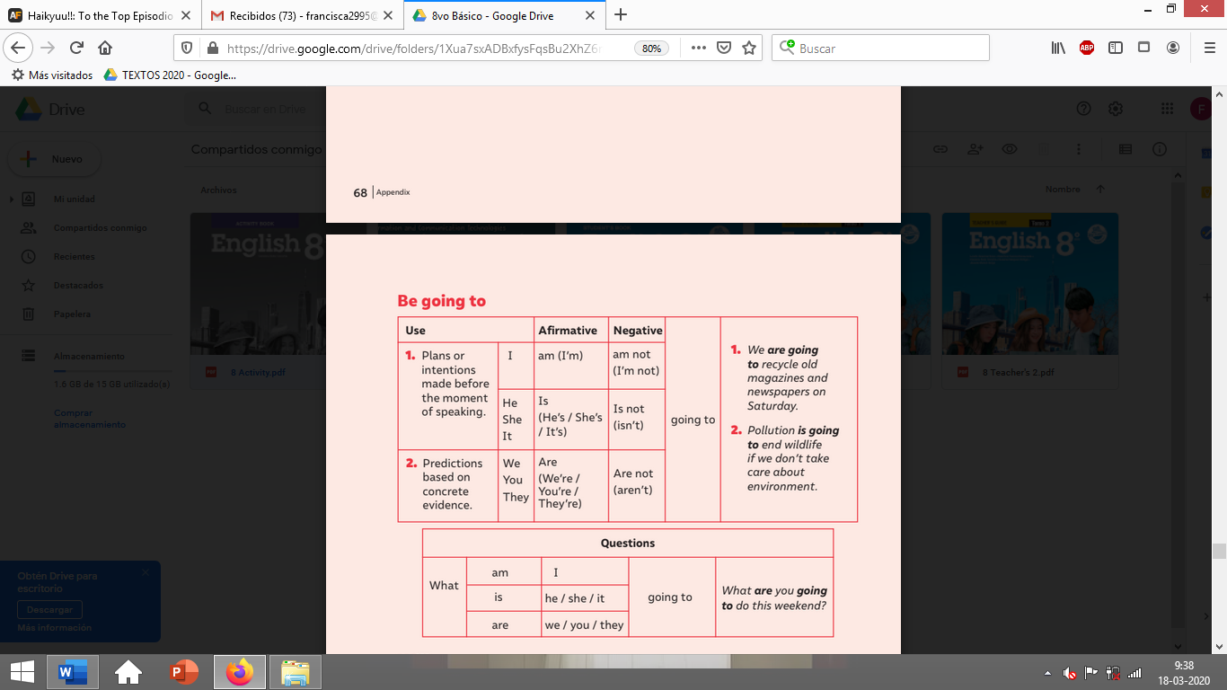
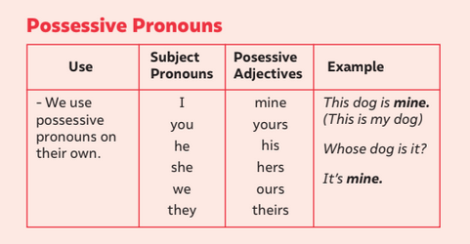

.

III. Should vs shouldn’t

Should: we use it to give advice, a recommendation or a suggestion
Examples
- Does your tooth still hurt? You should make an appointment with the dentist.
- I think you should study for the test so that you don't fail.
- Your hair is too long. You should get a haircut.
- You really should go to the new restaurant on Main Street.
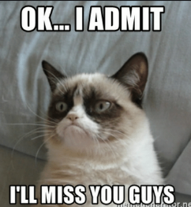
Shouldn’t: We use shouldn't to advise not to do something, usually because it is bad or wrong to do.
- You shouldn't throw your litter onto the street.
- We shouldn't leave without saying goodbye.
- He shouldn't play with those wires if he doesn't know what he is doing.
- Are you tired? You shouldn't work so much.
- You shouldn't talk like that to your grandmother.

Social Medias
I. Go to your ACTIVITY BOOK and complete the writing activity from page13 and 14. (20 pts)
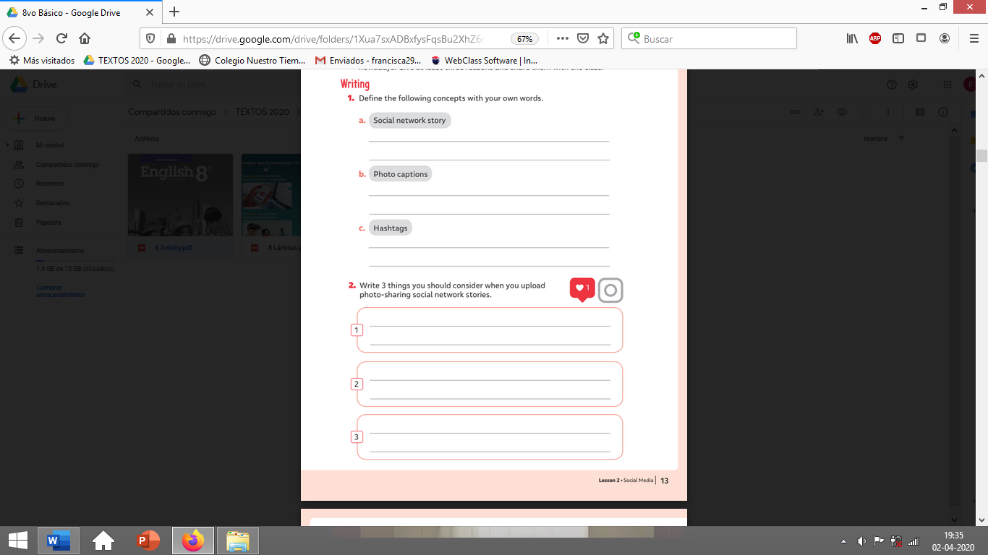

**USE SHOULD and SHOULDN’T to answer**

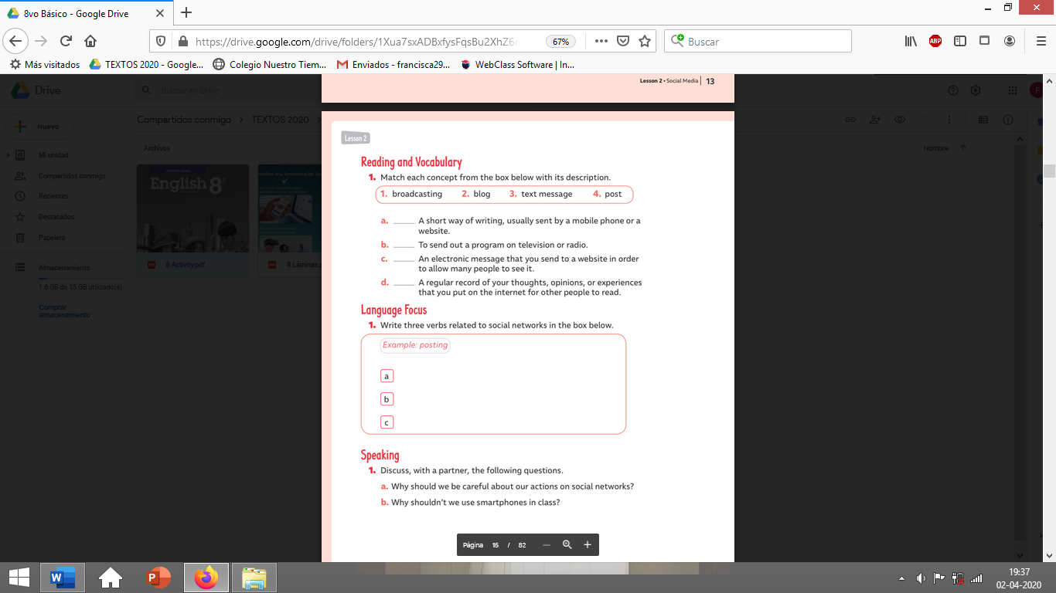

II. Go to your STUDENT’S BOOK and complete the activities from page 19 (10 pts). Feel free to use dictionary or google to help you in the tasks!
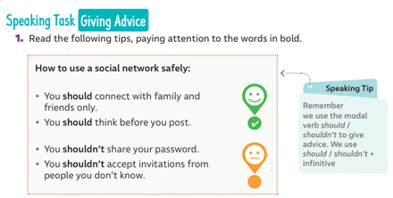

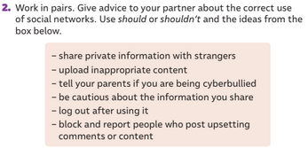

**USE SHOULD and SHOULDN’T to answer**

II. Go to your STUDENT’S BOOK and complete the activities from page 20 (10 pts). Feel free to use dictionary or google to help you in the tasks!
