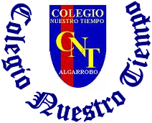

Colegio Nuestro Tiempo - R.B.D.: 14.507-6
Teacher of English Language: Francisca Alvarez P.
Guía de trabajo N°3
Idioma extranjero: Inglés
Sexto Básico
Semana 3

Name: ____________________________________________________________ Date: April 1st, 2020

Total score: 25 points Score: ____________ Mark: ___________________
OBJECTIVE | - To apply vocabulary related to Unit 1: Food and Health and third person singular rules.

Grammar reference
I. Personal pronouns.
We use the personal pronouns to replace people, places or things to make sentences shorter and clearer.
The personal pronouns are:
I am | You are | We are | They are | He is | She is | It is

II. Present simple
Present Simple Structure:

AFFIRMATIVE: S + VERB + COMPLEMENT

Example
I + drink + juice
He + eats + banana

NEGATIVE: S + DON’T + VERB + COMPLEMENT

Example
I don’t eat chicken
You don’t drink tea
We don’t cook
They don’t wash the carrots

S + DOESN’T + VERB + COMPLEMENT

Example
HE doesn’t eat eggs
SHE doesn’t drink milk
IT doesn’t smell good

INTERROGATIVE: DO + S + VERB + COMPLEMENT +?
DOES + S + VERB + COMPLEMENT +?

Example
Do I eat potatoes?
Do you drink water?
Do we eat spaghetti today?
Do they cook soup?
Does he eat onions?
Does she cook smash potatoes?
Does it drink water?
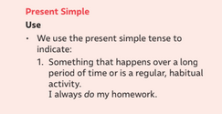

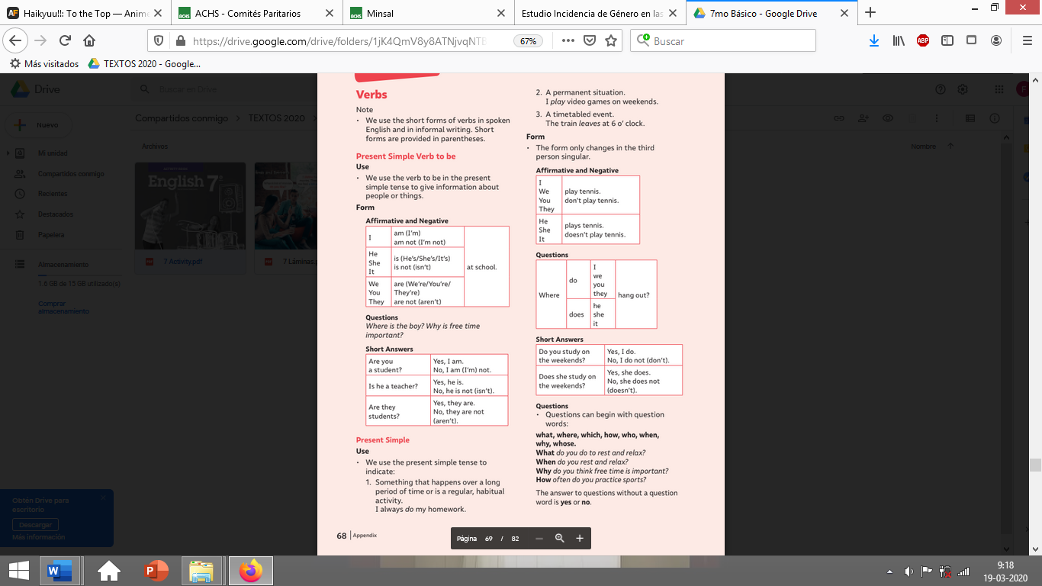

Grammar reference of the 3rd Person Rules

**REMEMBER**

We use DO/DON’T with personal pronouns:
I – YOU – WE – THEY

We use DOES/DOESN’T with personal pronouns:
HE – SHE – IT

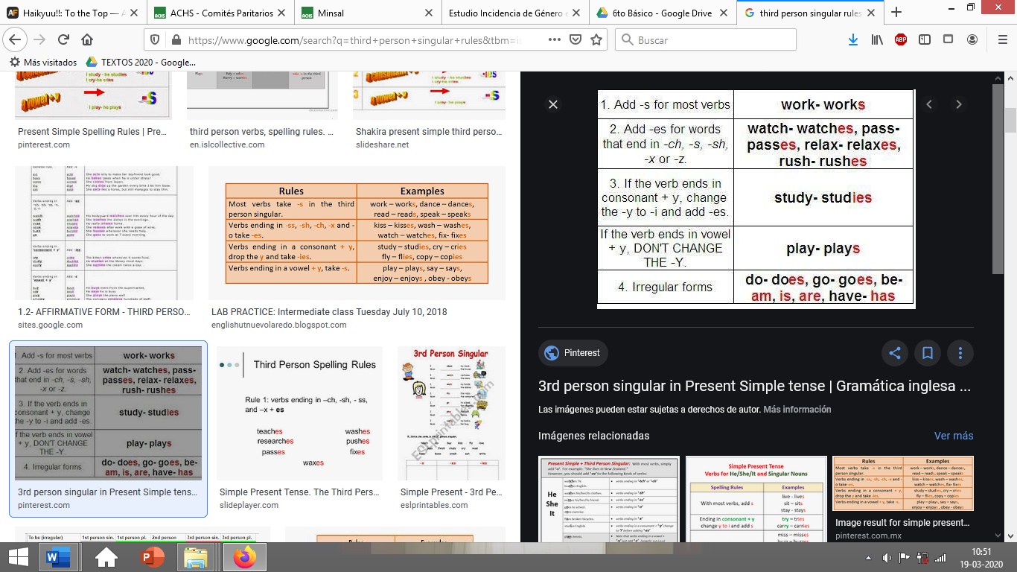

I. Look at the following sentences and choose the correct form of the verb. Add -S / -ES / -IES (7pts)

SLEEP - RAIN - FIX – STUDY – GO – LIVE - TAKE
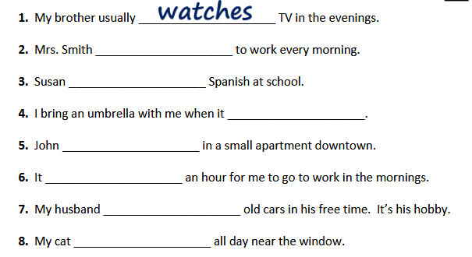

III. Translate the following words into Spanish. (6 pts)

a) CHEESE: _______________________ b) BOIL: _________________________________

c) MELT: _________________________ d) BREAD: ________________________________

e) BAKE: _________________________ F) BACON: _______________________________

II. Go to your STUDENT’S BOOK page 18 and complete activity 1. (2 pts)

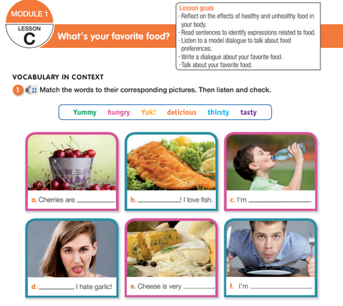

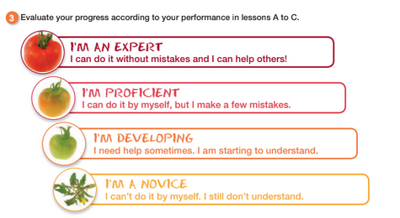
Choose the options that fits with your performance in worksheet 1 and 2.

