

Colegio Nuestro Tiempo - R.B.D.: 14.507-6
Teacher of English Language: Francisca Alvarez P.
Guía de trabajo N°3
Idioma extranjero: Inglés
Quinto Básico
Semana 3

Name: ____________________________________________________________ Date: March 31st, 2020

Total score: 24 points Score: ____________ Mark: ___________________
OBJECTIVE | - To apply vocabulary related to frequency adverbs and routines

Grammar reference
I. Personal pronouns.
We use the personal pronouns to replace people, places or things to make sentences shorter and clearer.
The personal pronouns are:
I am | You are | We are | They are | He is | She is | It is

II. Numbers from 1 to 50

1 one 6 six 11 eleven 16 sixteen 30 Thirty

2 two 7 seven 12 twelve 17 seventeen 40 Forty

3 three 8 Eight 13 thirteen 18 eighteen 50 Fifty

4 four 9 Nine 14 fourteen 19 nineteen

5 five 10 Ten 15 fifteen 20 twenty

Unit 1: Home time
Tidy my room  Ordenar mi cuarto | Walk the dog  Pasear el perro | See my friends  Ver a mis amigos | Have dinner  Cenar | Do my homework  Hacer la tarea
Go to bed  Ir a la cama | Do the dishes  Lavar los platos | Listening to music  Escuchar musica | Do sports  Hacer deporte | Play videogames  Jugar video juegos

Frequency adverbs

We use it to talk about how often something happens.

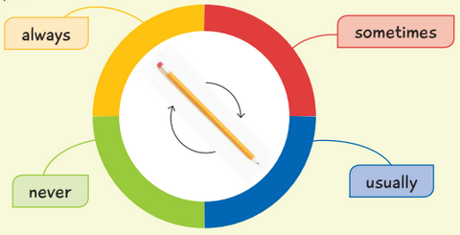
Always: Siempre

Usually: Usualmente

Sometimes: Algunas veces

Never: Nunca

Activites
I. Go to your ACTIVITY BOOK and complete the activities from page 14 related to FRECUENCY ADVERBS. (15 pts)
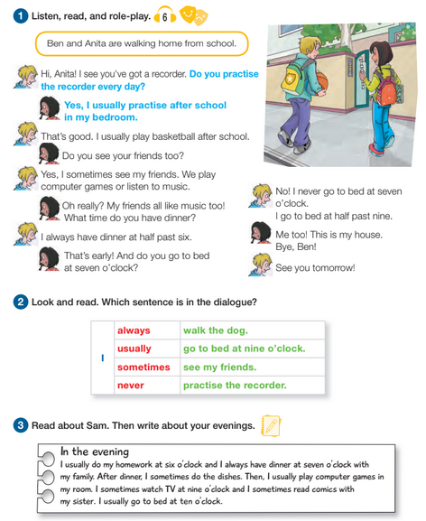

- Use the template in your ACTIVITY BOOK page 10 to write about your evenings.

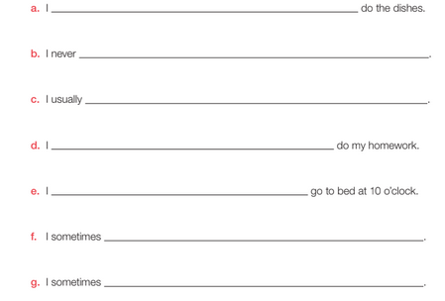
Template page 10

II. Complete the following schedule about your daily rutine in your home. (9 pts)

I wake up at: __________________ (Time)
I get up at: ____________________ (Time)
I have breakfast at: ______________ (Time)
I brush my teeth at: ______________(Time)
I watch tv or play games at ______________ (Time)
I have lunch at: ______________________(Time)
In the afternoon I: _____________________ (Activity)
In have diner at: ____________________ (Time)
I go to sleep at: _____________________ (Time)

