
Colegio Nuestro Tiempo - R.B.D.: 14.507-6
Teacher of English Language: Francisca Alvarez P.
Profesor de Artes Musicales: Cristóbal Baeza
Guía de trabajo N°10
Idioma extranjero: Inglés y Artes Musicales
Cuarto Básico

Name: ____________________________________________________________ Date: June 1st, 2020

Objectives | To identify vocabulary related to Unit 2: The city, means of transportation & occupations  To apply socioemotional skills

Activities
1. Write the number according to the picture. An example has been given. (13 pts)
1.CAR DRIVER 2. CAR 3. HOUSE 4. CYCLIST 5. BUS 6. WORLD 7. CABIN
8. BUS DRIVER
9. BICYCLE 10. APARTMENT 11. TAXI 12. CASTLE 13. TAXI DRIVER 14. City

 | 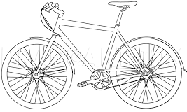 |  | 
  1 | 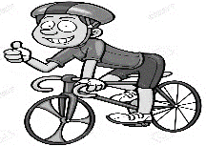 | 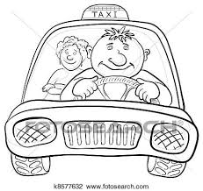 | 
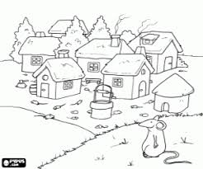  TOWN |  |   COUNTRY | 
 |  |  | 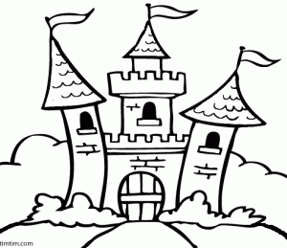

2. Complete the sentences using the words from activity 1. Clues have been given (6 pts)

a. Snow white lives in a ___________________________. Blanca Nieves vive en un Castillo.
b. Santiago is a __________________________________. Santiago es una ciudad.
c. Peru is a _______________________________________. Perú es un país.
d. A _______________________________ rides a bicycle. Un ciclista anda en bicicleta.
e. A __________________________________ drives a taxi. Un taxista maneja un taxi.
f. A ___________________________________ drives a bus. Un chofer de bus/micro maneja un bus o micro.

3. Read the following extract from the story “Snow White Goes to Town” and do the following activities:
a) Circle the words that you know. /Encierra las palabras que conoces. (4 pts)
b) Underline 4 words that you don’t know and write their definitions. / Subraya 4 palabras que no conozcas y escribe su definición. (4pts)
Example: b) Stepmother: MADRASTRA.
Chapter 1

Snow White lives with her stepmother in a castle. The castle is in the middle of the woods. Snow White and her stepmother live there alone.

Snow White’s father left the castle many years ago, and nobody knows where he is right now.
Snow White misses him a lot. She is a nice and clever girl, but she finds the castle too boring. She has already read all the books in the library, and the TV doesn’t work. So, she spends most of her time in the garden, playing hide and seek or football. But these games are not fun when you are alone.

Snow White’s stepmother is always too busy to play with her. She is a silly woman. She is always checking her magic computer and asking it questions.
The computer always answers the truth, because it’s magical.

Socioemotional activity “ I CAN SHOW KINDNESS!
IV. During this week apply the following advices and reflect on the importance of them. (5pts)
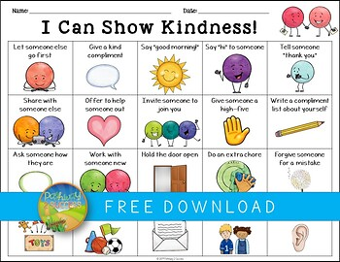  Meditate for 5 minutes | Give a kind compliment | Say “good morning” | Say “hi” to someone | Tell someone “ thank you”
Reflections in Spanish:

Actividad Música
Objetivo: Expresar sensaciones, emociones e ideas que les sugieren el sonido y la música escuchada, usando diversos medios expresivos (verbal, corporal, musical, visual).

Elige 3 canciones que hayas escuchado en los últimos días, y responde las siguientes preguntas:

- ¿Qué canciones elegiste?
- ¿Te gustan?
- ¿Quién te las mostró por primera vez?
- ¿Qué emoción te produce escucharlas?
- ¿Hay alguna canción especial que te haga sentir bien?
Recuerda!! : En caso de tener dudas o consultas sobre las actividades de alguna guía, no duden en escribir al correo idiomaextranjeroingles.cnt@gmail.com o al crisbamusica@gmail.com. Así mismo, si es posible tomar fotos y/o enviar las guías de trabajo de inglés realizadas para ser revisadas y entregar retroalimentación de sus trabajos.

